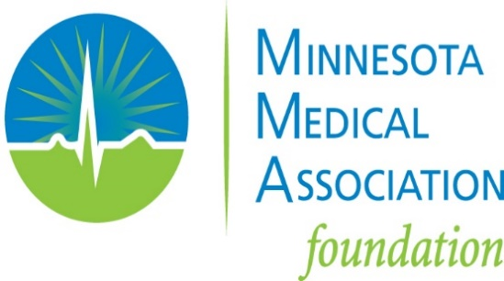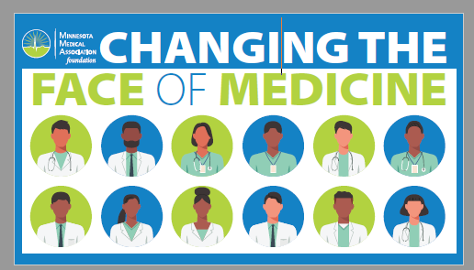
MMA FOUNDATION MCAT® FEE GRANT APPLICATION
An Initiative of the MMA Foundation’s Changing the Face of Medicine Program

CERTIFICATION PAGE

This page must be signed by the applicant and returned as the first page of the grant application.
All the information provided is complete and accurate to the best of my knowledge. I hereby give the Minnesota Medical Association Foundation permission to share this information for recruitment and public relations. I hereby certify that I am a resident of the state of Minnesota and am enrolled full-time as an undergraduate in a Minnesota college or university. I also hereby certify I will use the Minnesota Medical Association Foundation MCAT fee grant toward the expenses described in this scholarship application. Falsification of information will result in termination of any award granted. All application materials become the property of the Minnesota Medical Association Foundation.

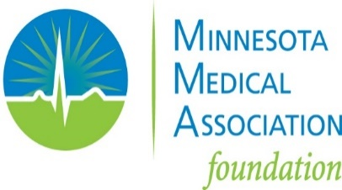
Please sign and date below:
Applicant Signature:

Applicant Name (print):

Date of Application:

MMA Foundation Medical College Admission Test® (MCAT®) Fee Relief Grant Application
The Minnesota Medical Association (MMA) Foundation is committed to changing the face of medicine to make medicine more diverse. As part of this commitment, we offer a limited number of grants each year to reimburse the MCAT® fees for Minnesota students in Minnesota colleges who meet our eligibility requirements. Funding preference for this program is to students from racial and ethnic populations underrepresented in the medical profession relative to their numbers in the general population, particularly those whose personal statement demonstrates financial need.

To complete a MMA Foundation MCAT® Fee Relief Grant application, please provide all the information requested below, and e-mail your completed application, including the signed certification page, personal statement, and letter of recommendation to: kgloege@mnmed.org.

APPLICANT INFORMATION
First and Last Names:

Permanent Address (name, address, city, state, ZIP):

E-mail Address: (This will be our primary means of contacting you.)

Telephone Number:

Name of the Minnesota College or University You Are Currently Attending:

Current Grade Point Average: (Please attach your current transcript. You must have at least a 3.5 GPA on a 4.0 system to be eligible for the MMA Foundation MCAT® fee relief grant.)

Funding Preference for this Program is to Students from Racial and Ethnic Populations Underrepresented in the Medical Profession Relative to Their Numbers in the General Population, Particularly Those Experiencing Financial Hardship. Please Share How You Identify Yourself:

What Date Did You Register to Take the MCAT® Exam and What Date Will You Take the Exam: (You must already be registered and have paid the fee for the MCAT® exam to be eligible for the MMA Foundation MCAT® fee relief grant. For 2023 MCAT fee relief grant applications, you must have registered for the MCAT ® exam on/after February 22, 2023.)

How Much Did You Pay Out of Pocket to Register for the MCAT® exam? (MMA Foundation grants will cover your actual out-of-pocket fees paid.)

Did You Also Apply for the American Association of Medical College’s (AAMC) MCAT® Fee Assistance Program? (The MMA Foundation encourages all applicants to apply for the AAMC MCAT® Fee Assistance Program prior to registering for the MCAT® exam. The AAMC MCAT® Fee Assistance Program includes discounted fees, complimentary access to the MSAR® online database, free MCAT® Official Prep products, and more.)
_____ Yes
_____ No

If You Did Not Apply for the AAMC MCAT® Fee Assistance Program, Please Use This Space to Help Us Understand Why:

If You Are Awarded a Grant, May We Contact You in the Future As Part of Our Program Evaluation?
_____ Yes
_____ No

PERSONAL STATEMENT
Please submit a personal statement supporting your application for MCAT® fee relief. (The personal statement should not exceed one page.)

LETTER OF RECOMMENDATION
Please submit one letter of recommendation, preferably from a school official who can discuss your achievements, your potential for future success, and your interest in attending a U.S. medical or osteopathic school.

2023 APPLICATION REQUIREMENTS
A complete application will include the following:
- Signed certification page
- Application
- Current college transcript
- Proof of MCAT exam registration (on/after Feb. 22, 2023)
- Proof of MCAT registration fee payment (on/after Feb. 22, 2023)
- Personal Statement
- Letter of recommendation

Thank you for completing this MMA Foundation MCAT® Fee Relief Grant application and for your interest in the MMA Foundation. This grant program is part of the MMA Foundation’s Changing the Face of Medicine Program. The MMA Foundation’s MCAT® Fee Relief Grant program is available year-round on a first-come, first-served basis. The MMA Foundation reserves the right to not award any grants during a calendar year.

